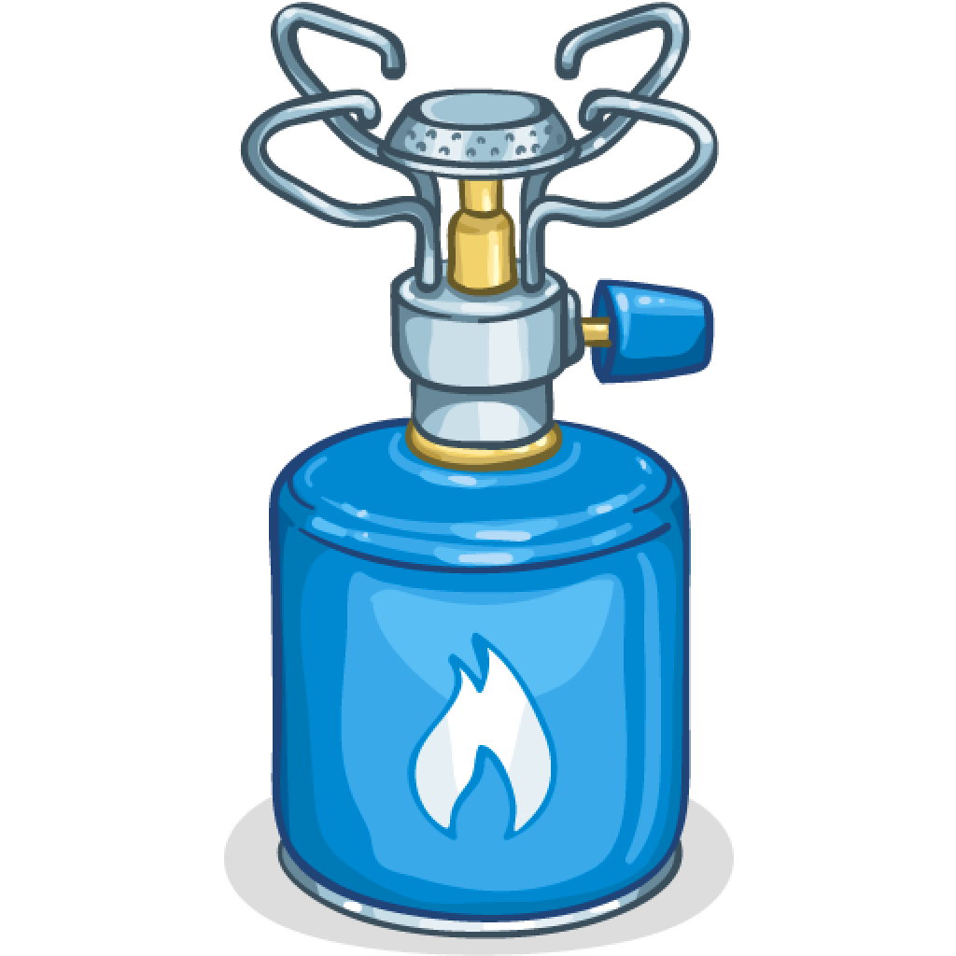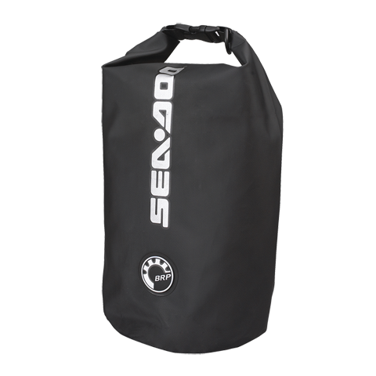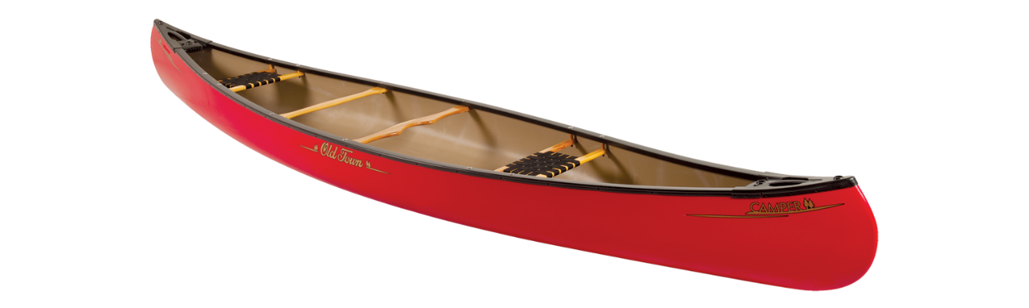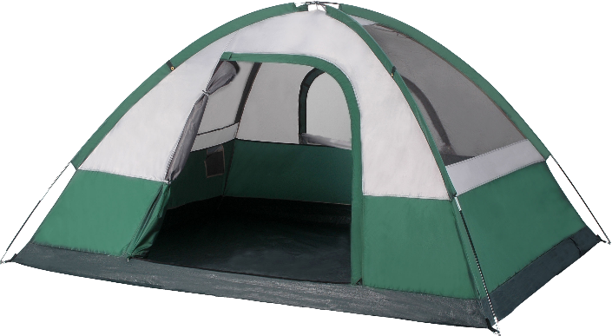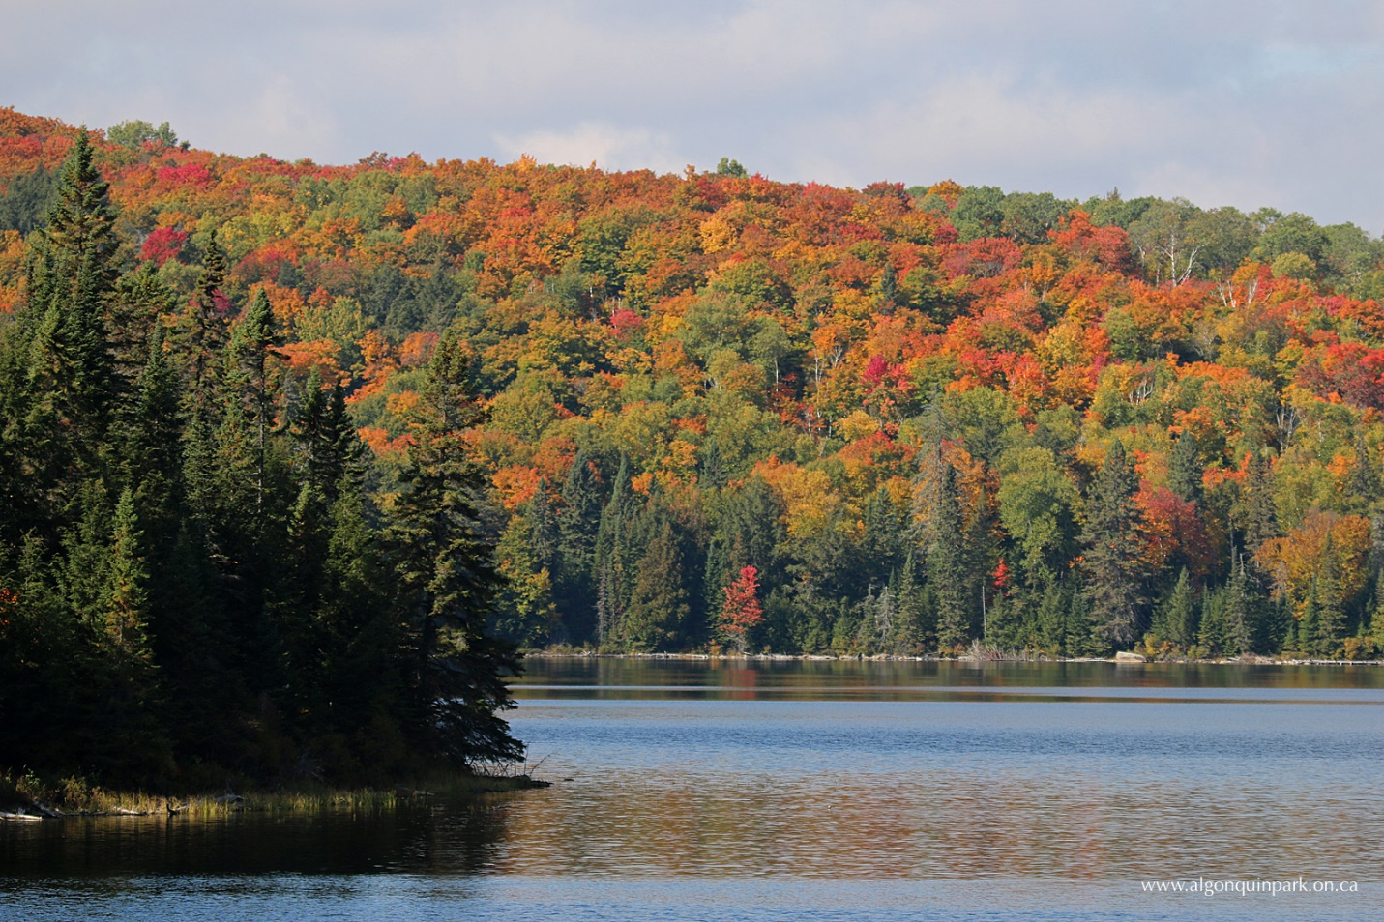

Planning a 4 day Canoe Trip

With

Owen Brake

**Table of Contents**

***Equipment and Material Lists*** 1

**Clothing (Per person)** 1

**Transportation** 1

**Cooking and Food Items** 1

First Day 1

Second Day 1

Third Day 2

Last Day 3

Extra food items 3

Cooking Tools and Equipment 4

**Cleaning** 4

**Sleeping** 4

**Shelter** 5

***Descriptions*** 5

**Equipment** 5

Tarp 5

4’ x 2’ folding table 5

Large picnic blanket 5

Sponge and J-Cloth 5

8 pairs of Heavy Socks 6

Strainer 6

**Food** 6

Chili 6

# ***Equipment and Material Lists***

## **Clothing (Per person)**

* 8 pairs of heavy socks
* 6 pairs of underwear
* 6 pairs of pants
* 6 pairs of shirts
* 1 Sweater
* 2 pairs of shoes
* 2 rain jackets
* 2 polypropylene outfits
  + Pants
  + Shirt
* Toiletries
  + E.g. Deodorant, toothbrush

## **Transportation**

* 3 canoes
* 9 paddles

## **Cooking and Food Items**

### First Day

* + Lunch(Sandwiches)
    - 18 slices of bread
    - 2 16oz packages of sliced meat
    - 2 heads of iceberg lettuce
    - 5 2lb blocks of cheddar cheese
  + Dinner(Tacos)
    - 9 lbs of ground beef
    - 2 more heads of iceberg lettuce
    - 500ml of sour cream
    - 20 flour fajitas
    - Use leftover cheddar cheese

### Second Day

* + Breakfast(Dry Cereal and Sliced Fruit)
    - 9 packs of one serve (1oz) cheerios
    - 9 Apples
    - 9 bananas
  + Lunch(Grilled cheese)
    - 9 slices of Kraft singles
    - 18 slices of bread
    - 1 14 oz. bottle of ketchup
    - Use leftover butter from the first lunch.
  + Dinner(Soup)
    - 12 ounces of dried vegetable soup
      * Will yield 208oz of total soup
        + ~3 cups a person
    - Add salt

### Third Day

* + Breakfast(Bagels)
    - 3 packs of bagels with 5 in each
      * Extra in case people want more
    - 1 28oz container peanut butter
    - Use leftover cheddar cheese if possible
    - Use leftover butter if possible
    - 2 bananas
  + Lunch(Salad)
    - 9 packs of 9-15 oz salad kits
      * E.g.
        + Caesar
        + Cobb
        + Greek
    - 36oz bottle of ranch dressing
  + Dinner (Vegetarian/No Meat Chili)
    - 2 Onions
    - 2 12oz cans of kidney beans
    - 2 12oz cans of black beans
    - 2 12oz cans of diced tomatoes
    - 1 7oz can of chipotle peppers in adobo sauce
    - 1 1oz bottle of garlic powder
    - 1 1oz bottle of cumin
    - If any extra cheese use that.

### Last Day

* + Breakfast(Oatmeal)
    - 5 cups of oats
    - 10oz of raisins
    - Can use leftover fruit
    - 200g of Semi-sweet chocolate chips
  + Lunch(Ploughman’s Lunch)
    - Use cheddar cheese
    - 1 9oz package of Triscuit crackers
    - 1 9oz package of rice crackers
    - 5 sliced apples
    - 3 sliced bananas
    - 1 jar of pickles
    - 3 full size carrots
  + Dinner(Spaghetti)
    - 2 12oz packages of dry spaghetti
    - 2 28oz cans of spaghetti sauce
    - 2 bell peppers
    - 2 onions
    - 1 table spoon of salt
    - Used leftover cheddar cheese

### Extra food items

* + 16oz bottle of olive oil
    - Can be used for any meal
  + 16oz container of salt
    - Can be added to any meal
  + 5oz of tabasco chipotle sauce
    - Can be added to any meal

### Cooking Tools and Equipment

* + 1 spoon, fork and knife for each person
  + 1 large serrated knife
  + 1 large plain edge knife
  + 1 camping stove
    - Two canisters of propane or butane
  + 2 pans
  + 2 pots
  + 1 unbreakable cup for each person
  + 9 plastic plates
  + 9 small plastic bowls
  + 1 Spatula
  + 1 4’x2’ folding table
  + 1 5-10ft2 picnic blanket
  + 1 20’x30’ Tarp
    - 4 3’ pieces of rope
  + 1 small cheese grater
  + 1 strainer

## **Cleaning**

* 2 20 liter transparent rectangular boxes
* 2 J-Clothes
* 1 sponge
* 4 garbage bags
* 2 rolls of Bounty paper towels

## **Sleeping**

* 1 sleeping bag for each person
* 1 sleeping or yoga mat for each person
* 1 blanket
* 1 pillow case
  + Stuffed with clothing

## **Shelter**

* 1 4 person tent
  + For female
* 1 4 person tent
  + For males
* 1 1 person tent
  + For teacher
* All tents contain required setup materials

# ***Descriptions***

## **Equipment**

### Tarp

One issue that occurs in the fall season is that of precipitation. You cannot cook in the rain. So my solution though it is flawed it is the most feasible fix. My solution is using a tarp, the tarp will be a 20’x30’ tarp which will be made of polyethylene which itself is waterproof and durable perfect for our uses. The tarp can act so the cooks can stay dry while cooking but also to attempt to shield the stove from the rain. . The tarp may also help protect people when eating. This solution provides the best balance of space efficiency as well as function. The tarp will be tied on 4 ends to trees or some other stationary object.

### 4’ x 2’ folding table

An extremely important issue that is often looked over is a platform to cook on. The table will be made have 4 metal legs which can fold in and a plastic top. I chose to use a 4’x2’ folding table, since it allows cooks to have a suitable space to cook on while being the most space efficient. I realized while making this list that one cannot possibly cook on the ground, everything would get contaminated and it is unsafe to cook close to the ground because you may light grass or other flammable, natural material on fire.

### Large picnic blanket

When camping an issue comes up of where to eat. You cannot eat inside the tent because it will get the tent messy and may attract animals which can cause dangerous situations. There is not enough space to carry a large table and chairs however there needs to be enough space for 9 people to eat on. So my solution is to bring a picnic blanket, this will allow 9 people to sit on so they do not get messy and it is very compact when folded. The picnic blanket will be made of wool so it is heavily water resistant and it is also comfortable to sit on. The 5-10ft2 blanket will be that size because it is large enough for 9 people and that it is compact enough for folding.

### Sponge and J-Cloth

Cleaning dishes and utensils is important for food safety and for making sure animals are not attracted to the camp site. However there is a second issue that is the protection of the environment and wildlife. It may seem intuitive to use dish soap or even biodegradable dish soap however dish soap cannot be used unless being 200ft away from a body of water or else the water may become contaminated. So the solution is to use hot water, J-Clothes and sponges, though it may take longer than using dish soap it will protect the environment and still remove the germs from the dishes.

### 8 pairs of Heavy Socks

Socks may seem very basic of an item to bring however they are critical to health and survival in the woods. Going to sleep with wet feet is very dangerous and can lead to health problems. Trench foot in World War One was caused by soldiers who wore wet socks due to lack of resources, this caused their feet to decay and go through necrosis of the feet. Trench foot can occur in a minimum of 13 hours so having wet socks for 4 days can be extremely risky. Having wet clothing will also significantly cool the body in cold temperatures when sleeping which can lead to many severe health problems. So the obvious solution is to bring 2 pairs of socks per day, one for the day time and one for the night time. It is also important to have heavy socks because they will warm your feet after they were probably very cold from the rest of the day.

### Strainer

One important tool for cooking is using a strainer. Without a strainer you cannot get rid of the excess water without losing part of the meal. When we were creating spaghetti we realized without a strainer we could not get rid of the excess water. We had to attempt to get as much out without losing noodles which resulted in disaster since we lost some noodles and not a lot of water came out. The strainer can be made of either stainless steel or of plastic. Stainless steel is good since it is very durable however steel is more thermally conductive than plastic so it is important to be aware that the handle may be hot. The holes in the strainer should also be very smaller since spaghetti can be thin and may escape the strainer if the holes are too big.

## **Food**

### Chili

Chili is a great meal to make when camping in the woods without refrigeration. It creates a perfect blend of nutrition, taste and space saving for a great meal when camping. We start by slicing the chipotle peppers and removing the seeds since they can be extremely spicy and then chopping the onions. Than we heat 1 table spoon olive oil until it begins to shimmer. We than add the onions to the amount desired into the pot. We then add the beans, tomatoes, chipotle peppers, adobo sauce, salt and spices and stir to mix. We than cook the chili until the consistency appears to be right it should take between 15-30 minutes. Any extra cheese can be used on the chili. This creates a chili with a great combination of flavors and a small bit of spice which will be very exciting considering 4 days in the woods can lead people to desire flavorful foods. This is a very flexible meal so different spices, ingredients, toppings and quantities can be changed or added if there is enough space in the food barrel. Also keep in mind that chipotle sauce and salt can be mixed with any meal and those who desire more spice may wish to add this to the chili.